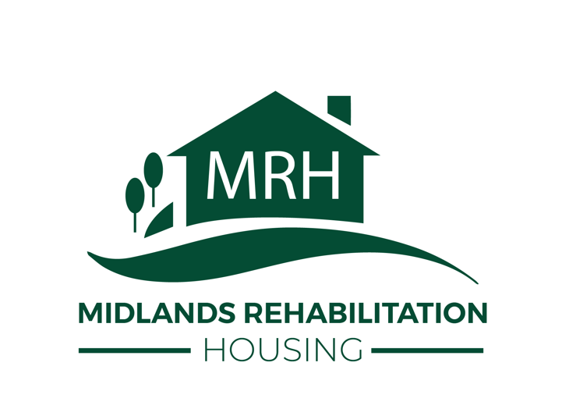 | Referral Form  Midlands Rehabilitation Housing  For supported housing / rehabilitation referrals

Please complete all relevant sections. Risk information must be provided fully where known. Email completed form to referrals@mrh.org.uk

1. Personal Details
Full Name |  | D.O.B
Address
Contact No |  | Nationality
NI Number |  | Date
Housing Aid Officer |  | Gender
Home link application |  | Home link reference no
Email address |  | Housing Aid Number

2. Current Accommodation tick all that apply
☐ Rough Sleeping | ☐ Private Rented Tenancy
☐ NCH Tenancy | ☐ Registered Social Landlord
☐ Bed & Breakfast | ☐ Friends and Family
☐ Supported Live In | ☐ Supported
☐ Owner Occupier | ☐ Hospital
☐ Prison | ☐ Other (please specify): __________________________

3. Current Situation
Why are they homeless? include cause, dates, current risks and any urgent factors

☐ Threatened with homelessness | ☐ At risk of homelessness

Referral Form
Midlands Rehabilitation Housing
Housing, health, family and income

4. Housing Situation
Where have they lived in the last 5 years? include dates, address/area, landlord/provider and reason for leaving

5. Health & Wellbeing tick all that apply
☐ Physical Disability | ☐ Alcohol Issues
☐ Learning Disability | ☐ Drug Issues
☐ Mental Health Issues | ☐ Other (please specify): __________________________

Health / wellbeing details and support required medication, diagnoses, treatment, support workers, appointments

6. Child / Family
Any children - names/DOB/social services involvement etc

7. Income tick all that apply
☐ Housing Benefit | ☐ JSA
☐ Council Tax Benefit | ☐ Tax Credits
☐ PIP | ☐ Universal Credit
☐ Pension | ☐ Begging
☐ Criminal | ☐ Other: __________________________

Referral Form
Midlands Rehabilitation Housing
Support needs and risk assessment

8. Current Support Needs & Support Network
Current support needs & support network family, friends, agencies, recovery support, daily living needs

Any mobility / access issues

9. Offending / Agency Involvement
Offending e.g. previous/current offending, arson/probation/agencies involvement

10. Risk Information complete fully where known
☐ Self-harm | ☐ Risk to children
☐ Self-neglect | ☐ Arson
☐ Sexual assault/offence concern | ☐ Violence/aggression
☐ Vulnerable adult | ☐ Domestic abuse
☐ Substance misuse risk | ☐ Other: __________________________

Risk details / explanation include dates, triggers, known incidents, current level of risk and safety measures

Referral Form
Midlands Rehabilitation Housing
Professional involvement and consent

Any Other Information

11. Other Agencies Support - Involvement
Professional Name | Role | Contact Number

12. Consent & Signatures
I give authorisation for my details to be shared with MRH.

Staff Sign |  | Date
Client Sign |  | Date
Print Name |  | Relationship to client

Office use / notes: ________________________________________________________________________________________________

